Asimov, ABC’s of Ecology, Walker 1972 First Ed. Fine unclipped DJ in Mylar price $4.50. Hardcover Xlibris Very Good book with first page after cover torn out. Library Discard stamps on inside of front cover and on title page. All other pages to 48 are tight and unmarked. ISBN 0802760988

ID 000123 Price $50 Box 24
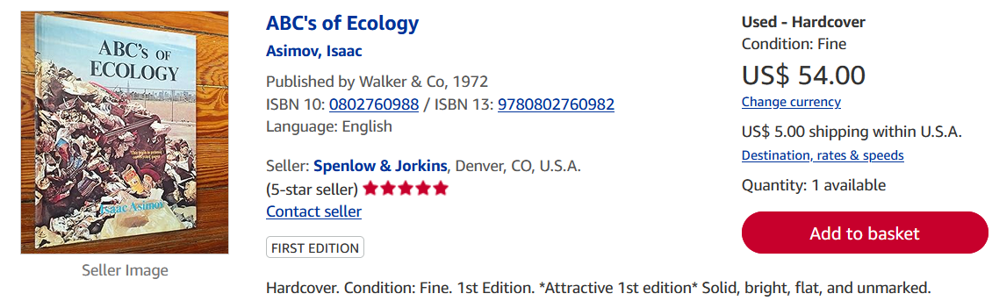
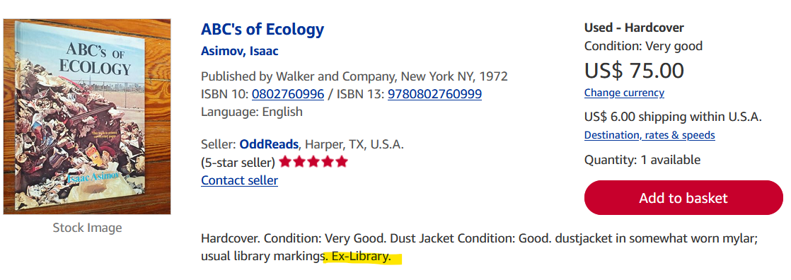
Amazon $56
Ebay
Biblio $75



